# Identity of the Raiders

The revolutionary raiders were members of the armory group led by Surya Sen as the leader and widely known as the ‘Master Da’. They believed the uprisings of the armed forces would help them as a way to establish an image of relief from the British Raj under India through decade long ruling power. They were roused by the 1916 Easter Rising in Ireland and driven by Surya Sen. Be that as it may, they were ideologically motivated more by the Communists in Soviet Russia. A large number of these marauders later became Communists.

The gathering included Ganesh Ghosh, Lokenath Bal, Ambika Chakrobarty, Harigopal Bal (Tegra), Ananta Singh, Anand Prasad Gupta, Tripura Sen, Bidhubhusan Bhattacharya, Pritilata Waddedar, Kalpana Dutta, Himangshu Sen, Binod Bihari Chowdhury, Subodh Roy, Monoranjan Bhattacharya. ("Chittagong armoury raid", 2020)

The raiders were revolutionary members among the important people involved in this conspiracy were Ganesh Ghosh, Lokenath Bal, Ambika Chkaraborty, Harigopal Bal ( Tegra ), Ananta Singh. ("The Chittagong uprising", 2010)

## Surya Sen

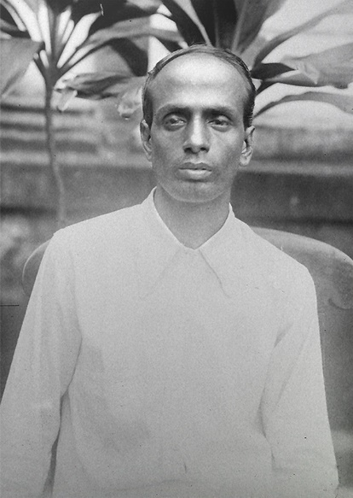"Surya Sen, a splendid and moving coordinator, was a simple, mild-mannered and straightforwardly earnest individual. Had tremendous and absolute boldness, he was profoundly conscious of others in his life. He was enamored with the saying: ‘Humanism is a special virtue of a revolutionary.’”, writes noted historian Bipin Chandra in his book India's Struggle for Independence 1857-1947. (Wangchuk, "Surya Sen, The Unsung Braveheart Whose Spirit Even Shattered Bones Failed To Break!", 2019)

Surya Sen was known widely by his supporters as the ‘Master Da’ which means School Teacher in English. He was the headmaster in the city of Noapara, Chittagong ( Now Bangladesh ). His movement for the Indian Freedom was established during his undergraduate studies at Berhampore College in 1916. He joined the Anushilan Samity, propelled by one of his instructors - established by Sarat Chandra Basu. Likewise, He workers with Chittaranjan Das - a political dissident who drove the Non-Cooperation Movement in Bengal and a solid promoter of peacekeeping. Sen was captured after the raid in Chittagong Armory for a long time back in 1926-28.

## Ganesh Ghosh

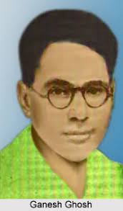Ganesh Ghosh was a Bengali Indian autonomy lobbyist, progressive and government official. Ganesh Ghosh hailed from Chittagong, presently in Bangladesh. In 1922, he took confirmation in the Bengal Technical Institute in Calcutta. Afterward, he turned into an individual from the Chittagong Jugantar party. He partook in the Chittagong ordnance strike, alongside Surya Sen and different progressives on 18 April 1930. He fled from Chittagong and took cover in Chandannagar, Hooghly. Following hardly any days police magistrate Charles Tegart assaulted the protected place of them in Chandannagar and captured him. One youthful individual progressive Jiban Ghoshal Alias Makhan killed by the police at the time of capture activity. After the preliminary, Ganesh Ghosh was expelled to the Cellular Jail in Port Blair in 1932. ("Ganesh Ghosh: The Asian Age Online, Bangladesh", 2019)

## Lokenath Bal

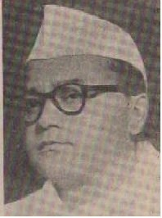Lokenath Bal was born on 8 March 1908 and died on 4 September 1964. He was also an Anushilan Samiti member and a leader of the Chittagong armory operation in 1930.

Lokenath Bal was brought up in the Chittagong of Bengal Presidency during the British Raj. After joining the Anushilan Samiti, he was picked by Surya Sen into the Chittagong Armory Raid group. Bal and Ganesh Ghosh were arrested on 1 September 1930 until 1946 after the attack. Bal became a member of the Indian National Congress, and he was a member of the administration of the Calcutta Corporation from 1952 to 1962. ("Lokenath Bal", n.d.)

## Ambika Chakrobarty

Ambika Chakrabarty was a member of the Chittagong Jugantar party. He took part in the Chittagong armoury raid led by Surya Sen. On the night of 18 April 1930, when the attack was planned by Surya Sen. He got to lead the team and was incharge of destroying the entire communication system in Chittagong. After 4 days, when there was a gunfight in the hill tracks of Jalalabad, Ambika and along with his team was seriously injured. Immediately, they escaped from the scene but after a few days he was arrested by the British police. He got arrested and condemned to death later on. However, the sentence was later changed to transportation for life to the Cellular Jail in Port Blair. ("Ambika Chakrabarty", 2020)

## Harigopal Bal (Tegra)

Harigopal Bal or Baulwas known as Tegra was a Bengali revolutionary who took part courageously in indian freedom movement against British ruling empire. He was also a part of the Chittagong Armory Raid. He died during the time of 22 April 1930

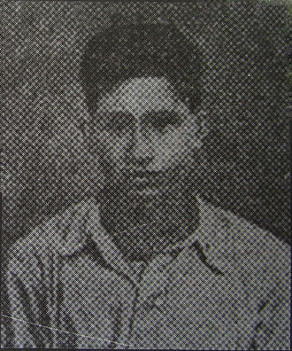

Born in the village of Kanungopara in Chittagong, Bengal (now in Bangladesh). The name of his father was Pran Krishna Bal. Bal joined the group of Surya Sen and was a fighter in planning and execution of the Chittagong Armoury Raid.. He was the younger sibling of Lokenath Bal. Bal could escape after the somewhat successful mission.However, As he was injured after being shot while fighting against British troops on Jalalabad Hill after 3 - 4 days. (PeoplePill, "Harigopal Bal: Indian revolutionary (born: n/a - died: 1930)", n.d.)

## Ananta Singh

Singh, Ananta was born during 1903 and died in the year of 1979. He lived his part of the life as an uprising raider, politician and one of the leading participants in the Chittagong Armoury Raid. Singh was born in Chittagong on 1 December 1903 while his father's name was Golap Singh.

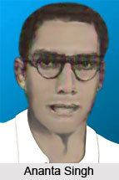

Singh’s journey on the Non-cooperation movement started during 1921. THis was his first movement in the history of British Indian Rule. It was said that he motivated his schoolmates to join the movement. However, he was criticised for personally not having much faith in the movement. According to the plan made by Surya SenSingh and Nirmal Sen was incharge of the robbery that took place at the treasury office of the Assam Bengal Railway. After that night on 14 December 1923, they got into a clash with the then British police after the robbery and were arrested on 24 December 1930.

He was also recognised for the knowledge of making bombs and cartridges for the people and the revolts for defence against the britishers..

## Pritilata Waddedar

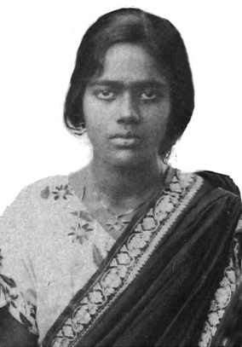Pritilata Waddedar was one the few revolutionary members of the Chittagong Armory Raid and played an influential part in the Indian independence movement, especially as a means for women empowerment. She was a student of Bethune College in Kolkata where she graduated from philosophy and later on became a school teacher.

Pritilata Waddedar was leading a group of fifteen revolutionaries during the armory attack planned by Surya Sen. She and her team carried out the plan of executing the Pahartali European Club where one of them was killed and eleven of them got injured. (Devakishen, et al., 2019) She did destroy the place but was later arrested by the police. As a part of the mission, She consumed cyanide and committed suicide to avoid being arrested.

## Kalpana Dutta

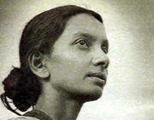Kalpana Dutta was another exceptional revolutionary born in that time. She was as influential as prithila during the Indian Independence Movement and joined the army led by Surya Sen. She was a member of the organisation Chhatri Sangha where she met Pritilata and through whom she later on got to know about Surya Sen. Therefore, she signed up to be part of the Chittagong raid.

Kalpana was incharge and responsible for the transport of the explosive and supplies from the attack where she was successful in knitting a cotton sack for the explosive to be a carrier. Through her research and scientific knowledge she was able to help the team to build a sustainable package for the transportation of the armories. She was also part of Pritilas planning on the raid. She was arrested by the British police before a week of the mission. We fled on bail and then helped with the plans of Prithila and Surya to torch the European Club. However, she was caught with others during the attack.

## Binod Bihari Chowdhury

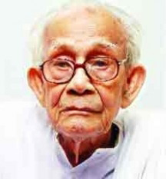Binod Bihari Chowdhury was another influential revolutionary among others who had a great impact on the Indian freedom movement and the Chittagong raid afterwards. He worked as a bangladeshi social worker and a veteran member of the civil society of Bangladesh.

During the year of 1927, Binod was a member of the anti-british group - Jugantar when he was suggested by a friend in school to join. Later he came to know Surya Sen and within a few days he became one of his trusted people in the group. After the plan was finally executed at 10 pm on 18 April 1930, Binod and his team mates were hidden in the Hills of Jalalabad taking shelter for the British police. Not for long she was hidden though. They were attacked immediately on 22 April where 80 Troops were killed of british police and 12 revolutionaries were dead. Rest of them were bought under trial and Binod was deported to the Detention camps in Rajputana. (Das, 2020)

## Subodh Roy

Subodh Roy, born in 1916 within a rich family at Chittagong during the time of undivided and unruled Bengal. At the age of 14, he was the youngest participant of all in the Chittagong armory raid. Roy was one of the few first people that were sentenced after the raid. He was then discarded to Cellular Jail in Port Blair during 1934.

During 1940 when he was released from Jail, The Communist Party of India took him in as a member and he entered into communist politics. After 1947, He moved to Calcutta to join as a whole timer of the Provincial Centre of the Party. (Chattopadhyay, 2006)

## Monoranjan Bhattacharya

Bhattacharya was born in Erikati, Faridpur District, British India. He participated in the progressive Madaripur gathering of Madaripur while a student. Bhattacharya took an interest in the Chittagong armory assault on 18 April 1930. (Chopra, P. N., 1969) His last activity was a mail sack burglary in Chamugaria on 14 March 1932. He acted upon a criminal offense by killing one post office worker when his act of robbery was caught red-handed.

Later on, After the almost successful raid, Bhattacharya and his four other colleagues were put in Faridpur Jail by the British police. He was declared to hang on 12 May 1932. And then executed In Barisal Regional Jail on 12 August 1932. Other co-accused were sentenced to various long terms of imprisonment. (Ghosh & Bhattacharya, 1998)

# Chittagong Armory Raid Plan

Surya Sen framed the idea and strategy of captivating the two main armories of the British in Chittagong. Afterward obliterating the telegraph and telephone office in the region to prevent troops from calling their central in Calcutta, to inform them about the attack. The plan also initiated with the butchery of members present in the "European Club '' situated in the port of Chittagong Armory.

Apparently these were the people involved in conserving the British Empire in India for years and years. These included officials from the military and government personnel. Surya Sen also planned to rob the British funded banks and firearms retailers to be raided. While rail lines and communication lines were to be cut off in order to disconnect Chittagong from Kolkata and this would eventually buy them more time to carry out the operation.

# Reference

Wikipedia contributors. (2020, April 4). Chittagong armoury raid. In Wikipedia, The Free Encyclopedia. Retrieved 15:22, May 28, 2020, from <https://en.wikipedia.org/w/index.php?title=Chittagong_armoury_raid&oldid=949014940>

Wikipedia contributors. (2019, May 9). Ambika Chakrabarty. In Wikipedia, The Free Encyclopedia. Retrieved 16:02, May 28, 2020, from <https://en.wikipedia.org/w/index.php?title=Ambika_Chakrabarty&oldid=896319185>

Wikipedia contributors. (2020, May 11). Pritilata Waddedar. In Wikipedia, The Free Encyclopedia. Retrieved 16:20, May 28, 2020, from <https://en.wikipedia.org/w/index.php?title=Pritilata_Waddedar&oldid=956093280>

Wikipedia contributors. (2020, May 20). Binod Bihari Chowdhury. In Wikipedia, The Free Encyclopedia. Retrieved 16:30, May 28, 2020, from <https://en.wikipedia.org/w/index.php?title=Binod_Bihari_Chowdhury&oldid=957884810>

Chopra, P. N., Chavan, Y. B., & India. (1969). Who's who of Indian martyrs. New Delhi: Ministry of Education and Youth Services, Govt. of India.

Chattopadhyay, S. (2006, September 21). Model revolutionary. Retrieved from https://frontline.thehindu.com/other/obituary/article30210972.ece

Das, U. S. (2020, April 10). Binod Bihari Chowdhury: Tribute to a revolutionary and a true patriot. Retrieved from https://tbsnews.net/panorama/binod-bihari-chowdhury-tribute-revolutionary-and-true-patriot-67438

Devakishen, B. A., Devakishen, B. A. D. B., Devakishen, B. A., Devakishen, B., University of East Anglia, & University of East Anglia. (2019, March 14). The Women Warriors of the Chittagong Armoury Raid: #IndianWomenInHistory. Retrieved from <https://feminisminindia.com/2019/03/15/women-warriors-chittagong-armoury-raid/>

Ganesh Ghosh: The Asian Age Online, Bangladesh. (2019, October 15). Retrieved from https://dailyasianage.com/news/200730/ganesh-ghosh

Ghosh, K. C., & Bhattacharya, S. (1998). *Chronological dictionary of Indias independence*. Calcutta: Sahitya Samsad.

Lokenath Bal. (n.d.). Retrieved from https://historica.fandom.com/wiki/Lokenath_Bal

PeoplePill. (n.d.). Harigopal Bal: Indian revolutionary (born: n/a - died: 1930). Retrieved from https://peoplepill.com/people/harigopal-bal/

The Chittagong uprising. (2010, December 2). Retrieved from https://www.hindustantimes.com/bollywood/the-chittagong-uprising/story-Oi3AqwFItKWb2edBGFFwIN.html

Wangchuk, R. N. (2019, August 8). Surya Sen, The Unsung Braveheart Whose Spirit Even Shattered Bones Failed To Break! Retrieved May 28, 2020, from https://www.thebetterindia.com/135249/surya-sen-revolutionary-freedom-struggle-chittagong/